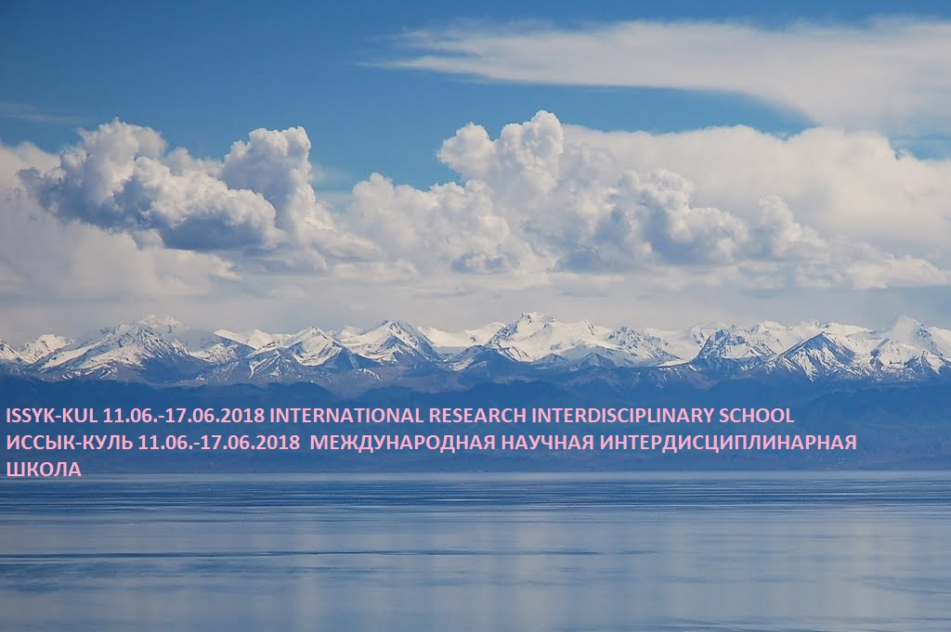

International Research Interdisciplinary School
IRIS Kyrgyzstan 2018
June 11-17, 2018, Bayet, Issyk-Kul (Kyrgyzstan)

Application Form

Your Details |  |  |  | Date and Venue  The 4-day workshop will be held from June 11 to June 17, 2018 (arrival June 11, departure July 17) in Bayet, 79th km of Balykchi-Karakol road.
Surname:
First Name:
Title / Position:
Institution/organization:
Address:
Payment by Bank Transfer

Bakaibank,
Bishkek, Kyrgyzstan
1242000372778416
Subject: IRIS 2018

City:
State:
Country:
Zip/postal code:
Phone:
Fax:
E-mail:
Payment
Fee: Euro 200 (covers accommodation, full board, program) |  |  |  | Contact:  Dr. Taalai Kudaiberdiev  3/1, Togolok-Moldo, (Bishkek) - Kyrgyzstan  T +996709696927  e-mail: cponics@mail.ru  Dr. Zarema Zhakypova  3/1, Togolok-Moldo, (Bishkek) - Kyrgyzstan  T +996553054216  e-mail: x0023330@gmail.com
Please, transfer the payment to the account by June 1, 2018
Signature: |  | Date:

