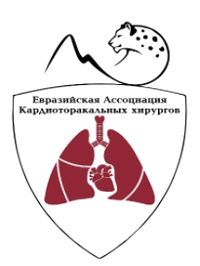 | «Eurasian Association of Cardiothoracic Surgeons»  www.eaacts.com е-mail: info@eaacts.com phone: +996 (312) 88 23 50

To the chairman of the Association
Doctor of Medicine S.D. Joshibaev

APPLICATION FOR RECEPTION TO MEMBERSHIP OF
«EURASIAN ASSOCIATION OF CARDIOTHORACIC SURGEONS » (ЕАCTS).

I, |  | ,
 | name and surname
am asking you to consider opportunity to accept me to membership in «Eurasian Association of Cardiothoracic Surgeons » (EACTS).
I undertake to comply with the provisions of the Charter.
I guarantee timely payment of membership fee.

Details
Place of work:
Position:
Contacts:
 | work phone |  |  | mobile phone |  | e-mail

.

____________________

«___» _______________2018

